Still--William

# Author: Richmal Crompton

## Author of the Report: Md Shahadat Hossen Nayem

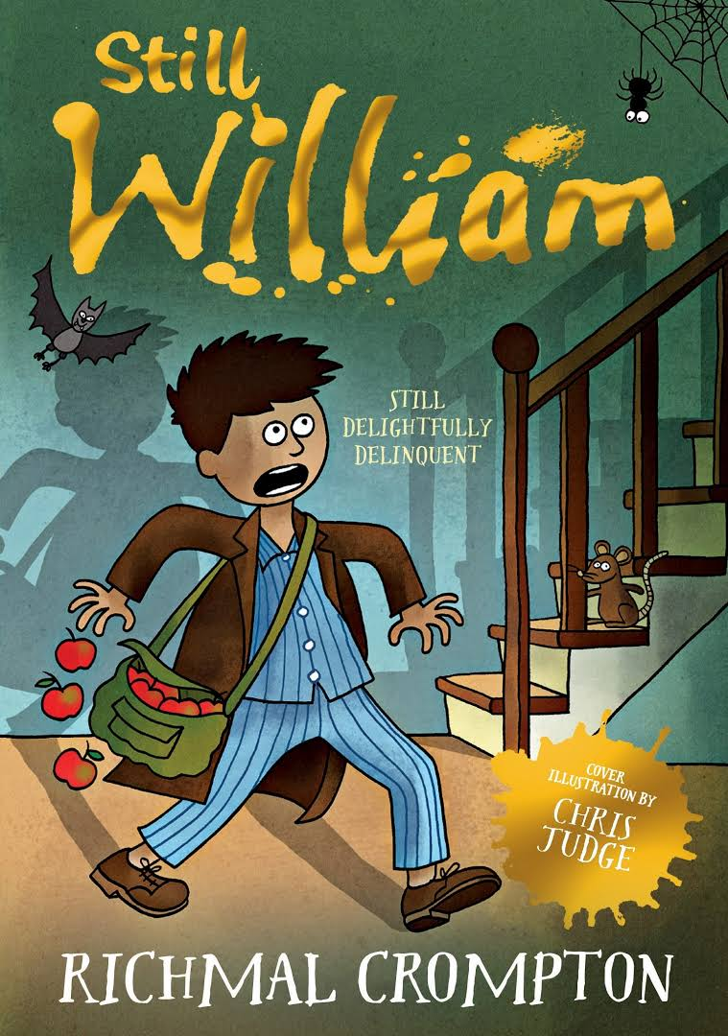

# Information Page

Length Distribution Plot  
**The plot is describing Chapter I***Total Length of Chapter I: 22003  
Number of paragraph in Chapter I:146  
Number of words in Chapter I:146*Words in Longest paragraph in Chapter I:110  
Words in Shortest paragraph in Chapter I:0

